**Manchester Metropolitan University**

Msc Computer Science - 2023/24

**Information Systems and Databases**

**Project Report**

Group A14

|  |
| --- |
| **Student Name** |
| Tha Lin Htet |
| Sampath Karunarathne Dedunupiti Gedara |
| Akhil Varma Mudunuru |
| Daniela Onyinyechukwu Achelus |
| Arsema Amare |

Table of Contents

Part I – Systems Analysis (& Design) 3

1. Executive Summary 3

2. Main goals of the system 3

3. Functional Requirements and the Non-Functional Requirements for the System. 4

4. Use Case Diagram (UCD) 5

5. Use Case Specifications (UCS) 6

Part II – Database Design & Implementation 9

1. Top-down Entity Relationship Diagram (ERD) for the Pet Clinic system*.* 9

2. Normalization & Bottom-Up ERD 10

2.1 Normalization - Pet Registration Form 10

2.2 Normalization - Appointment Diary 10

2.3 Normalization - Pet Consultation Form 11

2.4 Bottom-Up ERD from the Tables Produced at 3NF. 12

3 Final ERD After Merging Top-Down and Bottom-Up Data Models. 13

4 Creating Oracle Tables from the Design. 14

5 Inserting Data into the Created SQL Tables. 17

6 Retrieving All Data from Each Table using SELECT query. 18

7 Strategies to Redesign Our Database to Improve It for a Larger Client. 22

Part III – Query Implementation 23

1. SQL Statement 1 23

2. SQL Statement 2 23

3. SQL Statement 3 24

4. SQL Statement 4 24

5. SQL Statement 5 24

6. SQL Statement 6 25

# Part I – Systems Analysis (& Design)

## Executive Summary

Noah's Pet Clinic (NPC), a veterinary office in rural Manchester, specialized in canine care while providing treatment for various other types of pets. The purpose of this report is to analyse the existing system and to document the design of a new information system by utilising appropriate systems development methods and modelling techniques.

At present, the clinic faces inefficiencies in its registration and appointment management system which involves manual entry of appointments, registration forms, and consultation documents. The existing virtual filing system used for owner and pet registration forms also causes difficulties in retrieving necessary detail due to naming and organisation issues. Limited accessibility to the appointment diary poses obstacles for vet doctors and nurses. Use of different consultation document forms and inconsistent entry of data further complicate the matters.

These issues collectively hinder the clinic's overall effectiveness and customer satisfaction, requiring an introduction of a new information system to enhance the processes and data management. The proposed system will include:

* A centralized database designed to store comprehensive information, encompassing appointment details, registrations, consultations, and staff information of the clinic.
* A web-based system for pet owners to register themselves and their pets, streamlining the process of scheduling appointments and completing registrations.
* Management access to operational reports.

The report is divided into three parts. In Part I, the main goals of the system with the functional and non-function requirement are listed and a Use Case Diagram (UCD) with several Use Case Specifications are created. Part II involves drawing a top-down Entity Relationship Diagram (ERD) for the system and normalization of appointment diary, the pet registration form, the pet consultation form which lead to producing a bottom-up ERD. Subsequently, Oracle database tables from the design is created and sample data is inserted. In Part III, sample SQL scripts are written to extract results from the tables created in Part II.

## Main goals of the system

The primary goal of the new system for Noah’s Pet Clinic is to improve the efficiency and accessibility of current appointments, registration systems, and the data management processes. The current manual appointment and registration processes are laborious/cumbersome, involving receptionists in scheduling appointments, tracking any changes through a diary appointment, and transcribing pet registration and consultation forms into virtual folders. This labour-intensive approach poses challenges for the veterinary staff, who relies heavily on this to carry out their tasks smoothly, which has become a source of inefficiencies.

Based on these revelations, the new/upgraded system aims to:

* Integrate a robust online pet registration system that simplifies the data entry, retrieval, and management of pet and owner information, resulting in increased efficiency and a better customer experience.
* Provide a dependable, simple, and easily available digital appointment & medical record management system for pet owners, vet nurses, doctors, and the management, reducing potential errors associated with manual entry.
* Offer a seamless automated fees and cancellation process.

This system will not only modernise NPC’s operational capabilities, but it will also underline the company's dedication to offering high-quality pet care services.

## Functional Requirements and the Non-Functional Requirements for the System.

1. **Functional List**

**Pet Owner**

* Must be able to register a new pet.
* Must be able to book, reschedule & cancel appointments.
* Must be able to Make an enquiry.

**Receptionist**

* Must have the functionality to view upcoming appointments.
* Must be able to receive enquiries and answer them.

**Doctors & Nurses**

* Must have the functionality to view upcoming appointments.
* Require the ability to access & update pet health records.

**Administration/Management**

* Need reporting tools to review clinic operations & records.

1. **Non-Functional Requirements:**

* The system must **support simultaneous use by multiple users** and be **available all the time.**
* **Regular backups** of all records to prevent data loss.
* **Access controls** should be availablefor staff according to their job roles to ensure pet owner data from unauthorized access and modification.
* **Search Functionality** to quickly retrieve pet and owner information.
* The system must **automatically calculate fees** based on the pet's age and apply a £5 fee for applicable **appointment cancellations.**
* **Automated Reminders** to pet owners for upcoming appointments and cancellations.
* **Pet ID** should be unique and within the range of 1000-3000.
* **Unique appointment numbers** should be generated by the system for each appointment.
* Pet **appointment dates** can only be allowed on Monday or Friday.
* Appointments should not be processed if the **pet’s age is more than 12 years.**
* **Doctors’ email addresses** must be **unique.**
* Making it **mandatory to enter certain data** during pet registration, appointment booking and pet diagnosis.
* To be **easy to use** for pet owners, doctors, nurses, and receptionists.

## Use Case Diagram (UCD)

## Use Case Specifications (UCS)

|  |
| --- |
| 1. **Use Case: *Register Pet Owner & the Pet*** |
| Owner: Pet Owner |
| **Pre-Conditions** |
|  |
| **Post-Conditions** |
| 1. Pet owner and pet’s information are stored in the system database. |
| **Primary Path** |
| 1. Pet Owner accesses the clinic's registration gateway. 2. Pet Owner completes the registration form with the personal detail of the Pet Owner and submits it. 3. The system creates a new Pet Owner record in the database. 4. Pet Owner is then prompted to enter the detail of the pet. 5. Pet Owner completes the pet registration form and submits it. 6. The system creates a new pet record in the database and establish a link between the pet and the respective pet owner. 7. An email confirmation is sent to the Pet Owner & Receptionist confirming the successful registration of both the pet owner and the pet. |
| **Alternate Path** |
|  |
| **Notes** |
|  |
|  |
|  |

|  |
| --- |
| 1. **Use Case: *Register A New Pet Under an Existing Pet Owner*** |
| Owner: Pet Owner |
| **Pre-Conditions** |
| 1. Pet owner should be already registered in the system database. |
| **Post-Conditions** |
| 1. New pet’s information is stored in the system database with the link to the pet owner. |
| **Primary Path** |
| 1. Pet Owner accesses the clinic's pet owners profile page. 2. Pet Owner then select add new pet option, completes the pet registration form, and submits it. 3. The system creates a new pet record in the database and establish a link to the respective Pet Owner. 4. An email confirmation is sent to the Pet Owner & Receptionist confirming the successful registration of the pet. |
| **Alternate Path** |
|  |
| **Notes** |
|  |
|  |
|  |

|  |
| --- |
| 1. **Use Case: *Make Appointments*** |
| Owner: Pet Owner |
| **Pre-Conditions** |
| Pet Owner and the pet must be registered in the clinic’s system. |
| **Post-Conditions** |
| The appointment is scheduled successfully. |
| **Primary Path** |
| 1. Pet Owner logs in to the appointment scheduling system. 2. System displays available time slots to the user. 3. Pet Owner selects a preferred time slot. 4. System sends an email to the Pet Owner, Receptionist, and the Veterinary Doctor, confirming the appointment. 5. Pet Owner makes the payment to the Receptionist prior to the appointment. |
| **Alternate Path** |
| If no slots are available for the preferred time, the requester (Pet Owner) is advised to select a different time slot. |
| **Notes** |
|  |
|  |
|  |

|  |
| --- |
| 1. **Use Case: *Cancel Appointments*** |
| Owner: Pet Owner |
| **Pre-Conditions** |
| An appointment must exist in the system. |
| **Post-Conditions** |
| The appointment is cancelled, and the time slot is made available for another appointment.  A cancellation fee is applied for the next appointment by the system, if the appointment is cancelled on the same day as the appointment date. |
| **Primary Path** |
| 1. Pet Owner logs in to the system and navigates to the existing appointments section. 2. Pet Owner selects the appointment that needed to be cancelled. 3. System displays the clinic’s policy on the cancellation prior to the confirmation. 4. Pet Owner confirms cancellation and system updates the schedule. 5. An email confirmation of the cancellation is sent to the Pet Owner, Receptionist, and the Veterinary Doctor. 6. Receptionist processes the refund if a payment is already done for the appointment. |
| **Alternate Path** |
|  |
| **Notes** |
|  |
|  |
|  |

|  |
| --- |
| 1. **Use Case: *Update Pet Medical Records*** |
| Owner: Veterinary Doctor |
| **Pre-Conditions** |
| The pet must be registered in the system. |
| **Post-Conditions** |
| Pet's medical records are updated with new information. |
| **Primary Path** |
| 1. Veterinary Doctor logs into the system and accesses the pet's medical records. 2. Veterinary Doctor concludes the pet examination and/or treatment. 3. Veterinary Doctor updates the pet records with new health condition, treatments done, and any prescriptions. 4. System validates the required details and saves the updates. |
| **Alternate Path** |
| If the system cannot validate the updates made, the Veterinary Doctor is prompted to review the information and resubmit. |
| **Notes** |
|  |
|  |
|  |

# Part II – Database Design & Implementation

## Top-down Entity Relationship Diagram (ERD) for the Pet Clinic system*.*

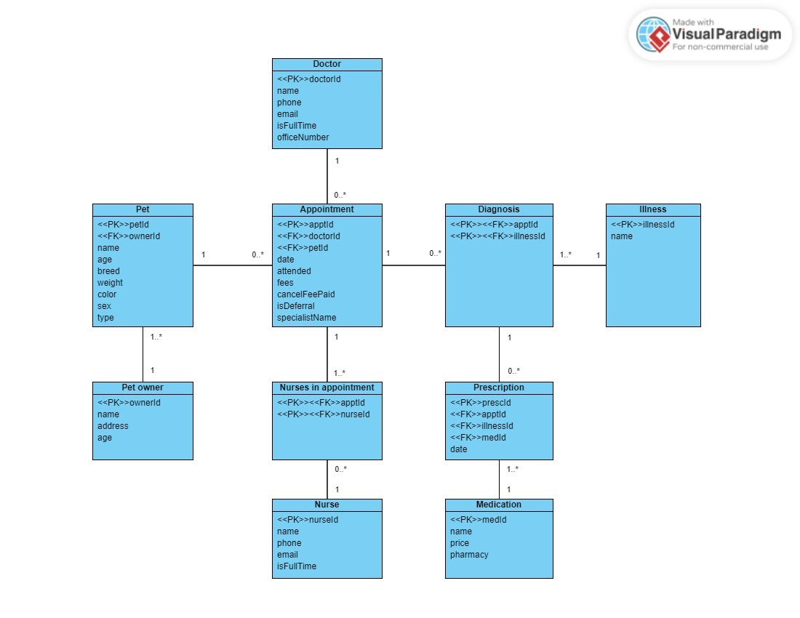

## Normalization & Bottom-Up ERD

### Normalization - Pet Registration Form



### Normalization - Appointment Diary



### Normalization - Pet Consultation Form



### Bottom-Up ERD from the Tables Produced at 3NF.

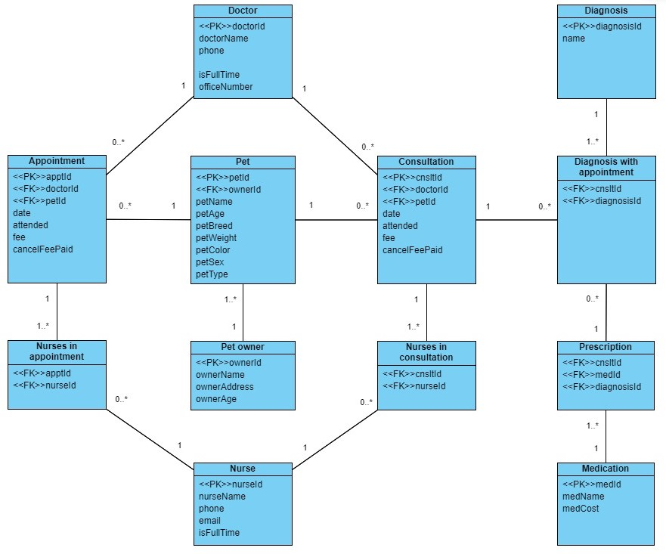

## Final ERD After Merging Top-Down and Bottom-Up Data Models.

Following is our finalized ERD, which was subsequently used to create the database.

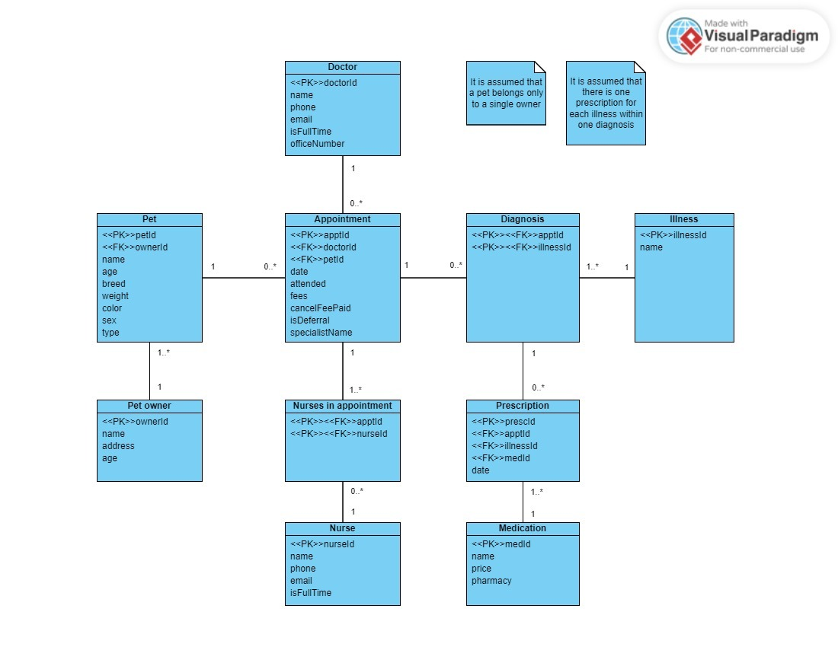

We believe our ERD could be further improved as follows.

In addition to Doctors and Nurses, we can also incorporate the detail of receptionists, maintenance staff and cleaners working at the clinic by adding a new entity as "Other Workers". This entity would have attributes such as worker ID, name, phone number, job title, availability etc. The job title attribute could be used to distinguish between different types of workers.

Similarly, it may be also useful to store a database of pharmacies in the system by creating a new entity for pharmacies and adding attributes such as the pharmacy’s address, phone number, etc. However, there will be a many-to-many relationship between the medication entity and the pharmacy entity as a medication can be retrieved from multiple pharmacies while multiple medications can be available at a single pharmacy. As a result, creation of a weak entity will also be required.

Furthermore, following additional attributes/features could also be add to the existing entities.

* Pet: Allergies, Date of Birth (Age to be calculated automatically)
* Doctor: Specialty.
* Medication: Dosage, Side Effects (to look for)
* Pet Owner: Payment Information (for online booking)

In addition to the above suggestions, the relationship between the pet entity and the pet owner entity in our final ERD was made with the assumption that a pet can only belong to an individual pet owner. However, there can be instances where a pet belongs to more than one pet owner, resulting many-to-many relationship with the necessity of creating a new weak entity.

## Creating Oracle Tables from the Design.

We have used following SQL statements to create SQL tables to store the data.

*(Please refer* ***groupA14.sql*** *file submitted herewith for more detail – applicable from section 4 to 6).*

**DROP SQL Statements**

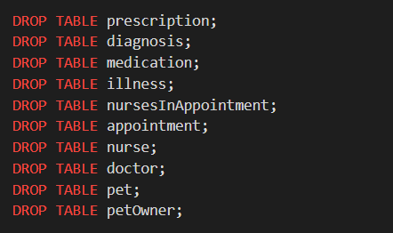

**CREATE SQL Statements for the tables.**

## Inserting Data into the Created SQL Tables.

**Example INSERT statements for each table created above.**

* **PET OWNER**

**

* **PET**

**

* **DOCTOR**

**

* **NURSE**

* **APPOINTMENT**



* **NURSE IN APPOINTMENT**

**

* **ILLNESS**

**

* **DIAGNOSIS**

**

* **MEDICATION**

* **PRESCRIPTION**

## Retrieving All Data from Each Table using SELECT query.

* **PET OWNER**

* **PET**

* **DOCTOR**

* **NURSE**

* **APPOINTMENT**

* **NURSE IN APPOINTMENT**

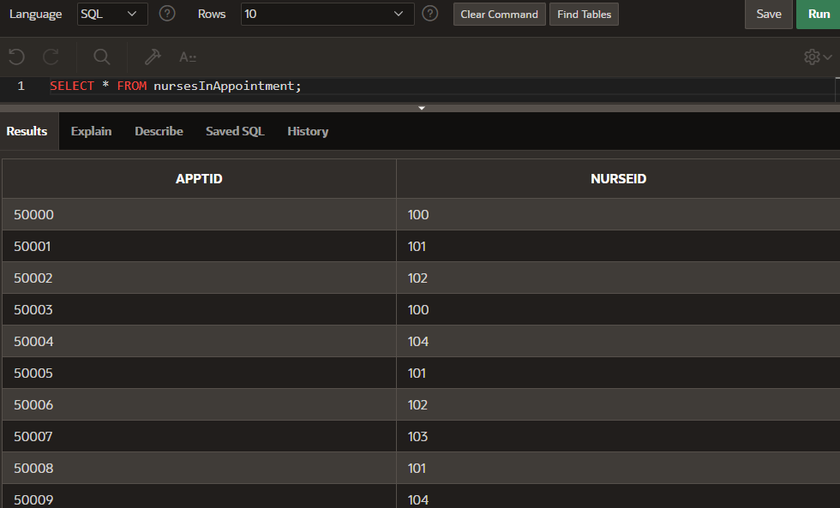

* **ILLNESSA screenshot of a computer

  Description automatically generated**
* **DIAGNOSIS**

* **MEDICATION**

* **PRESCRIPTION**

## Strategies to Redesign Our Database to Improve It for a Larger Client.

Currently, our database is tailored for a small veterinary clinic, accommodating the registration of less than 3,000 pets. The system is optimized for operation only two days per week by limited number of users. It also includes limited unique ID ranges for doctors, pet owners, nurses, and appointment IDs, all tailored to this specific requirement. In the context of a larger veterinary franchise, the volume of data generated by larger number of stakeholders would be significantly greater, necessitating adjustments to the existing database.

One aspect would be choosing a scalable numbering system that allow scalability such as using alphanumeric characters for the ID (e.g. – Doctors ID could start from DOC00001, Appointment ID could start from AA00001 and extending up to AZ99999). This also involves changing the data type and the length of the ID fields in the database tables. This allows for a more extensive pool of unique identifiers, accommodating the larger number of stakeholders in a large veterinary franchise while reducing the risk of exhausting the ID range. Additionally, it will lead to more distinctive and easily identifiable identification of records, improving user experience when dealing with large volume of data.

Furthermore, data generated at each location is only relevant for that franchise. However, as the database is accessed by diverse users across various locations, there arises a risk to data security. To mitigate this risk, it is essential to implement an access control measures for the database. This involves in identifying and defining the user roles and the access level to the database based on their requirement and the responsibilities. For an example, doctors may have permissions to read and modify patient records while their access to view financial records are restricted. Individual user accounts can be created for each user and above roles can be assigned accordingly. Adhering to access control measures can also be a regulatory requirement in the data protection laws. Failure to implement such measures can result in legal penalties and reputational damages. Further this will help in reducing potential risk of data breaches, identity theft, and other security incidents.

As the volume of data records in the database tables grows, while a substantial number of users accessing the system, there is a potential for reduced performance. To mitigate this issue, partitioning can be introduced. This involves dividing the database tables into smaller, more manageable segments based on certain criteria (such as franchise location, user type), which will lead to a smoother and more efficient database operation within the franchise.

# Part III – Query Implementation

## SQL Statement 1

Following SQL statement lists the pet id, pet name, pet age showing the columns as “ID”, “Name” and “Age”. Their names start with letters A to M. Results are sorted by the pet id in descending order.

## SQL Statement 2

Following SQL statement shows the most overworked part-time vet doctor, (i.e., any vet with 3 or more appointments for pet clinics, listing details such as doctorId, doctorName, and doctorOfficeNumber)

## SQL Statement 3

Following SQL statement lists pet details with 2 or more appointments between 2nd Jan 2023 and 26th Sep 2023. (The columns include petId, petName and a count of the number of appointments.)

## SQL Statement 4

Following SQL statement finds petId, petName and cost of appointments, where the cost of the appointment is less than the average appointment cost of all pet appointments.

## SQL Statement 5

Following SQL statement lists doctor id, status, the total number of appointments he/she has handled, the pet involved (id, name) and the dates these took place. The query only shows cases whose diagnoses involved “lack of Socialisation” or “Dental Issues” work and where the appointment date was at least 4 weeks ago.

## SQL Statement 6

Following SQL query finds pet ids with no appointments or diagnoses so far.

